1 | Word | Meaning | Example(s) | Image
 | accurate  ac•cu•rate  adjective | right or 100% _______________ in every detail | Students can check to see if their calculations are accurate with a ____________________  The __________________ forecast from our local news station is usually accurate. | 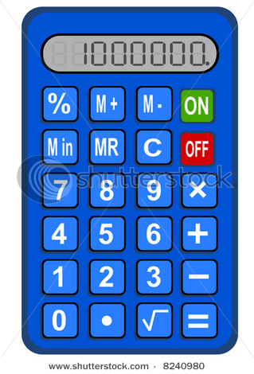

Verbal Practice (Think-Pair-Share-Write):
Students can check to see if their spelling is accurate with a
Writing Practice (Think-Write-Pair-Share):
In my opinion, the television program presents
an view of the life of American children like me.

2 | Word | Meaning | Example(s) | Image
 | factor  fac•tor  noun | one of many things that __________ or affect a situation | The weather is often a factor in the Superbowl. If it ________, the athletes don’t perform well.  A good night’s sleep and a nutritious breakfast are factors in a student’s performance on ________________________. | 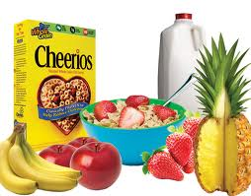

Verbal Practice (Think-Pair-Share-Write):

One of the most important factors when I purchase a gift for a friend is

Writing Practice (Think-Write-Pair-Share):
Several influence my interest in a book, in particular
and

